**Assignment**

1. **List the customers who are in California in the city San Diego**

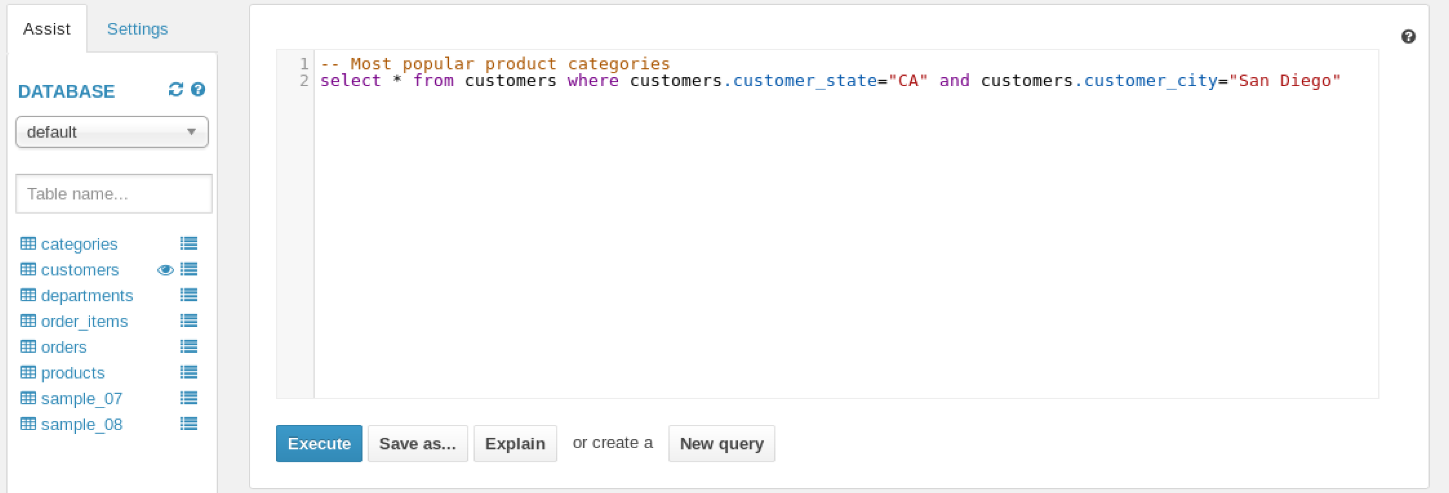

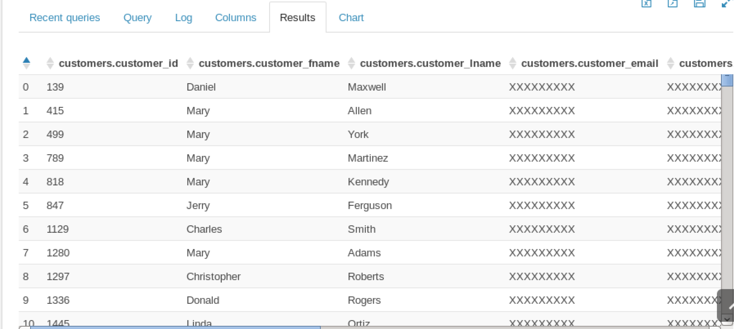

1. **In the sample_08 data set - who had the highest salary in 2008?**
2. **Chief Executives**
3. **Anesthesiologists**
4. **Surgeons**
5. **Lawyers**

